**Buliding effective page and background image**

<!DOCTYPE html>

<html lang="en">

<head>

    <meta charset="UTF-8">

    <meta http-equiv="X-UA-Compatible" content="IE=edge">

    <meta name="viewport" content="width=device-width, initial-scale=1.0">

    <title>Before And After Pseudo selector</title>

    <style>

        body {

            background-color: black;

            color: white;

            margin: 0px;

            padding: 0px;

            /* web page background image  */

            /* background: url(https://images.unsplash.com/photo-1508138221679-760a23a2285b?ixlib=rb-1.2.1&ixid=MnwxMjA3fDB8MHxwaG90by1wYWdlfHx8fGVufDB8fHx8&auto=format&fit=crop&w=774&q=80)

            no-repeat center center/cover; */

            /* the above statement to not repeat image and bring its center cover on web page */

        }

        header::before{

            background: url(https://images.unsplash.com/photo-1508138221679-760a23a2285b?ixlib=rb-1.2.1&ixid=MnwxMjA3fDB8MHxwaG90by1wYWdlfHx8fGVufDB8fHx8&auto=format&fit=crop&w=774&q=80)

            no-repeat center center/cover;

            content: "";

            position: absolute;

            top: 0;

            left: 0;

            width: 100%;

            height: 100%;

            /* now in order to show the content of web page use z-index */

            z-index: -1;

            opacity: 0.5;            /* to lightebn the image */

        }

        /* to make all the navbar in horizontally appearance use flex here */

        .navigation {

            display: flex;

            font-size: 20px;

        }

        li {

            padding: 23px 34px;

            list-style: none;

        }

        h3 {

            font-size: 40px;

        }

        section {

            display: flex;

            flex-direction: column;

            margin: 3px 200px;

            align-items: center;

            /* border: 2px solid purple; */

            height: 300px;

            /* since i incresed its height i want to make content in the center of the box also*/

            justify-content: center;

            /* prpoerty of flex boox  */

        }

        /* lets say if i want to insert any content after section  -- before or after pseudo selector */

        section::before {

            content: "This is content before section";

        }

        section::after {

            content: "This is content after section";

        }

        p {

            text-align: center;

        }

    </style>

</head>

<body>

    <header>

        <nav class="navbar">

            <ul class="navigation">

                <li class="item">Home</li>

                <li class="item">About</li>

                <li class="item">Services</li>

                <li class="item">Contact Us</li>

            </ul>

        </nav>

    </header>

    <section>

        <h3>Welcome to Coding World</h3>

        <p>Lorem ipsum dolor sit amet consectetur adipisicing elit. Eum consequatur ut est soluta, corrupti aperiam

            rem repellendus provident ipsum tempora? Sequi officiis et voluptatum neque aspernatur tempore labore

            eligendi magnam?</p>

    </section>

    <hr>

</body>

</html>

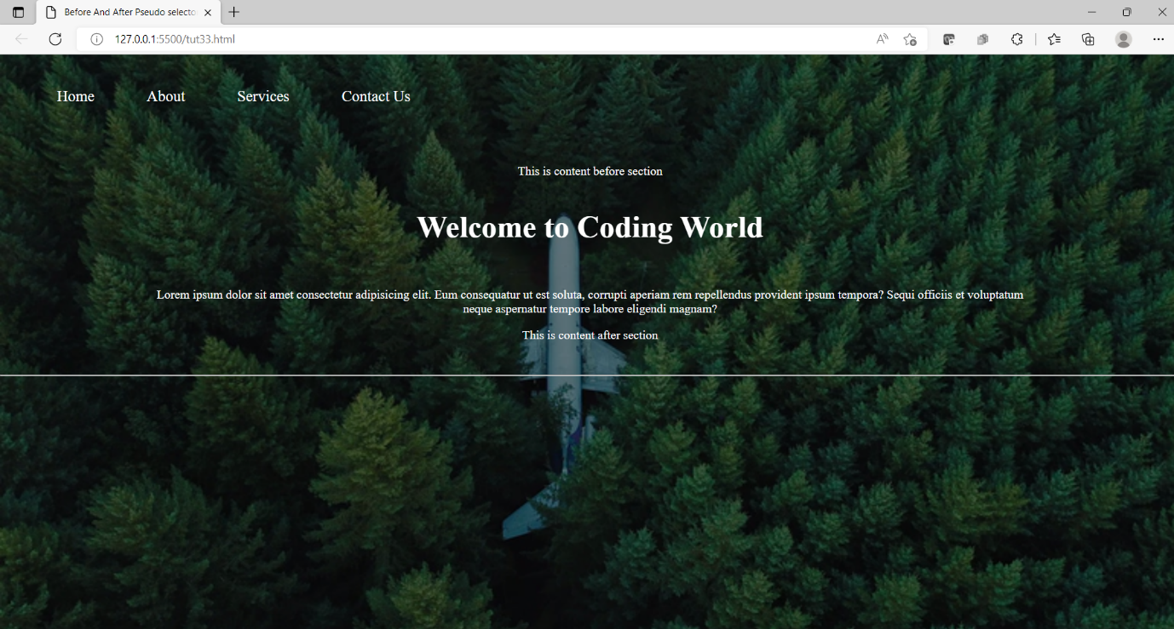

CSS Opacity / Transparency

[❮ Previous](https://www.w3schools.com/css/css_pseudo_elements.asp)[Next ❯](https://www.w3schools.com/css/css_navbar.asp)

The opacity property specifies the opacity/transparency of an element.

Transparent Image

The opacity property can take a value from 0.0 - 1.0. The lower value, the more transparent:



opacity 0.2



opacity 0.5



opacity 1  
(default)

Example

img {  
  opacity: 0.5;  
}

[Try it Yourself »](https://www.w3schools.com/css/tryit.asp?filename=trycss_image_opacity)

Transparent Hover Effect

The opacity property is often used together with the :hover selector to change the opacity on mouse-over:





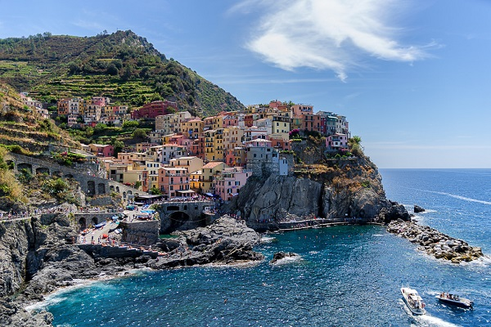

Example

img {  
  opacity: 0.5;  
}  
  
img:hover {  
  opacity: 1.0;  
}

[Try it Yourself »](https://www.w3schools.com/css/tryit.asp?filename=trycss_image_transparency)

Example explained

The first CSS block is similar to the code in Example 1. In addition, we have added what should happen when a user hovers over one of the images. In this case we want the image to NOT be transparent when the user hovers over it. The CSS for this is opacity:1;.

When the mouse pointer moves away from the image, the image will be transparent again.

An example of reversed hover effect:







Example

img:hover {  
  opacity: 0.5;  
}

[Try it Yourself »](https://www.w3schools.com/css/tryit.asp?filename=trycss_image_transparency2)

ADVERTISEMENT

Transparent Box

When using the opacity property to add transparency to the background of an element, all of its child elements inherit the same transparency. This can make the text inside a fully transparent element hard to read:

opacity 1

opacity 0.6

opacity 0.3

opacity 0.1

Example

div {  
  opacity: 0.3;  
}

[Try it Yourself »](https://www.w3schools.com/css/tryit.asp?filename=trycss_opacity_box)

Transparency using RGBA

If you do not want to apply opacity to child elements, like in our example above, use **RGBA** color values. The following example sets the opacity for the background color and not the text:

100% opacity

60% opacity

30% opacity

10% opacity

You learned from our [CSS Colors Chapter](https://www.w3schools.com/css/css_colors.asp), that you can use RGB as a color value. In addition to RGB, you can use an RGB color value with an alpha channel (RGBA) - which specifies the opacity for a color.

An RGBA color value is specified with: rgba(red, green, blue, *alpha*). The *alpha* parameter is a number between 0.0 (fully transparent) and 1.0 (fully opaque).

**Tip:** You will learn more about RGBA Colors in our [CSS Colors Chapter](https://www.w3schools.com/css/css3_colors.asp).

Example

div {  
  background: rgba(76, 175, 80, 0.3) /* Green background with 30% opacity */  
}

[Try it Yourself »](https://www.w3schools.com/css/tryit.asp?filename=trycss_opacity_box2)

Text in Transparent Box

**This is some text that is placed in the transparent box.**

Example

<html>  
<head>  
<style>  
div.background {  
  background: url(klematis.jpg) repeat;  
  border: 2px solid black;  
}  
  
div.transbox {  
  margin: 30px;  
  background-color: #ffffff;  
  border: 1px solid black;  
  opacity: 0.6;  
}  
  
div.transbox p {  
  margin: 5%;  
  font-weight: bold;  
  color: #000000;  
}  
</style>  
</head>  
<body>  
  
<div class="background">  
  <div class="transbox">  
    <p>This is some text that is placed in the transparent box.</p>  
  </div>  
</div>  
  
</body>  
</html>

[Try it Yourself »](https://www.w3schools.com/css/tryit.asp?filename=trycss_transparency)

Example explained

First, we create a <div> element (class="background") with a background image, and a border.

Then we create another <div> (class="transbox") inside the first <div>.

The <div class="transbox"> have a background color, and a border - the div is transparent.

Inside the transparent <div>, we add some text inside a <p> element.